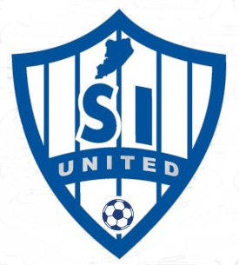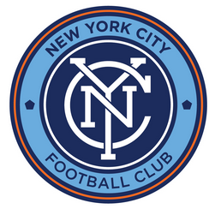
Statenislandunited.org
Staten Island United Soccer Club
Player/Parent Code of Conduct
Staten Island’s Largest Travel Club
play soccer at a higher level
The following should be read and followed by coaches, players and parents:
- Always remember you are a representative of Staten Island United and your demeanor both on and off the field are a reflection of our club. Poor sportsmanship and inappropriate behavior will not be tolerated.
- Avoid any use of violent force, obscene or abusive language towards another coach, player, spectator or referee. Failure to comply will result in suspension.
- Always respect the decisions and judgments made by the referee.
- Never ridicule or yell at your own child, another player or an opposing player.
- Players are to abide by the decisions and instructions given by a coach or a member of his/her coaching staff.
- The head coach is responsible for the actions of his or her players, parents, and assistant coaches. They are expected to maintain order on both sidelines. Failure to maintain order will result in a warning, a yellow or red card, and possible suspension. If a coach is carded he/she may be asked to leave the side line. If a coach receives two yellows or a red card, he/ she will receive a minimum of a two game suspension and a league determined fine. If a player receives two yellows or a red card, he/she will receive a minimum of one game suspension. Each incident will be reported to the league and reviewed by its board of directors for any further penalty.
- Persistent or aggravated rowdy behavior by a parent may result in that person being prohibited from attending games. If a person refuses to leave, the player associated with the parent will be pulled from the game and not allowed to play. If warranted, the player will be suspended from the club and prohibited from re-signing with Staten Island United.
- Parents are reminded that members of the coaching staff are volunteers. Any disagreement regarding coach’s decisions or methods should be discussed privately with the coach in an adult manner. Confrontations with the coaches will not be tolerated. If further resolution is needed, it will be addressed by the board of directors.

Players Name/Team: ______________________________________________________________________

Parent’s Signature: ________________________________________________ Date: ________________

